Designing Data Intense Applications: Chapter 1
Reliable
- Types of Faults
  - Tolerating Hardware and software faults
    - Hardware Failure
      - Hard disks crash, RAM becomes faulty, the power grid has a blackout, someone unplugs the wrong network cable
    - Software Failure

  - Human error
- We want a system that works correctly even when faced with adversity
- Performs what it was designed to do
- Performance is good under excepted load and data
Scalable
- Just because it is working now does not mean it will work under load
- The ability to cope with load
Measuring Load and Performance
  - Latency percentiles
  - Throughput
Maintainability
- Operability
- Simplicity
- Evolve able
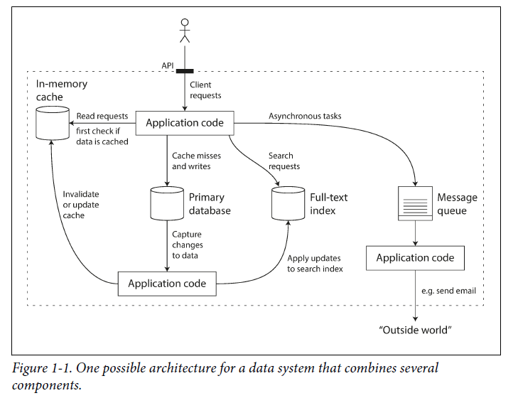
Data Systems

Data Storage
- Store data so that they, or another application, can find it again later (databases)
- Remember the result of an expensive operation, to speed up reads (caches)
- Allow users to search data by keyword or filter it in various ways (search indexes)
- Send a message to another process, to be handled asynchronously (stream processing)
- Periodically crunch a large amount of accumulated data (batch processing)

Creating a Reliable System
RAID configuration
Dual power and hot swappable CPUs
Batteries and diesel generators for backup power
Common for virtual machines to become unavailable without warning
- Platforms designed for flexibility and elasticity

Load
Load is described with a few numbers called load parameters
- Requests per second to a web server
- Ratio of reads to writes in a database
- Hit rate on a cache

